- Explainable AI refers to a set of processes and methods that aim to provide a clear and human-understandable explanation for the decisions generated by AI and machine learning models.
- Integrating an explainability layer into these models, Data Scientists and Machine Learning practitioners can create more trustworthy and transparent systems to assist a wide range of stakeholders such as developers, regulators, and end-users.

Building Trust Through Explainable AI
Here are some explainable AI principles that can contribute to building trust:
- Transparency. Ensuring stakeholders understand the models’ decision-making process.
- Fairness. Ensuring that the models’ decisions are fair for everyone, including people in protected groups (race, religion, gender, disability, ethnicity).
- Trust. Assessing the confidence level of human users using the AI system.
- Robustness. Being resilient to changes in input data or model parameters, maintaining consistent and reliable performance even when faced with uncertainty or unexpected situations.
- Privacy. Guaranteeing the protection of sensitive user information.
- Interpretability. Providing human-understandable explanations for their predictions and outcomes.

ARCHITECTURE
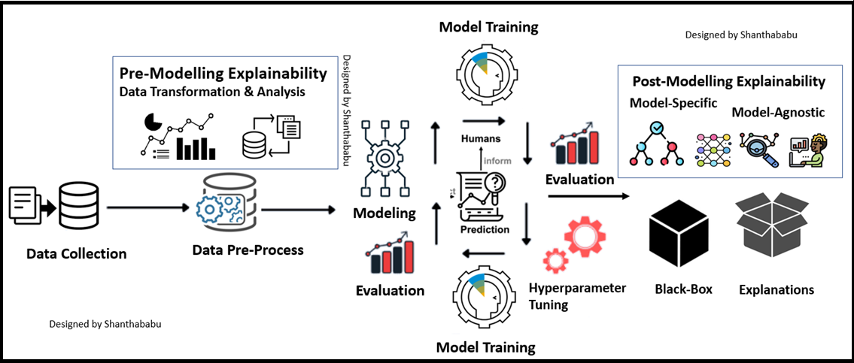

There are two broad categories of model explainability:
- model-specific methods and
- model-agnostic methods.
Both techniques can offer valuable insights into the inner working of machine learning models while ensuring that the models are effective and accountable.

Model-agnostic methods
These methods can be applied to any machine learning model, regardless of its structure or type.
They focus on analysing the features’ input-output pair.

SHAP
- It stands for SHapley Additive exPlanations.

- This method aims to explain the prediction of an instance/observation by computing the contribution of each feature to the prediction.
- SHAP offers an array of visualization tools for enhancing model interpretability, and the next section will discuss two of them: (1) variable importance with the summary plot, (2) summary plot of a specific target, and (3) dependence plot.

LIME
- Local Interpretable Model-agnostic Explanations (LIME).

- Instead of providing a global understanding of the model on the entire dataset, LIME focuses on explaining the model’s prediction for individual instances.

Model-specific methods
- As opposed to model-agnostic methods, these methods can only be applied to a limited category of models.

- Some of those models include linear regression, decision trees, and neural network interpretability.

- When using a decision-tree model, a graphical tree can be generated with the plot_tree function from scikit-learn to explain the decision-making process of the model from top-to-bottom
